2.7 Student Satisfaction Survey (SSS) on overall institutional performance

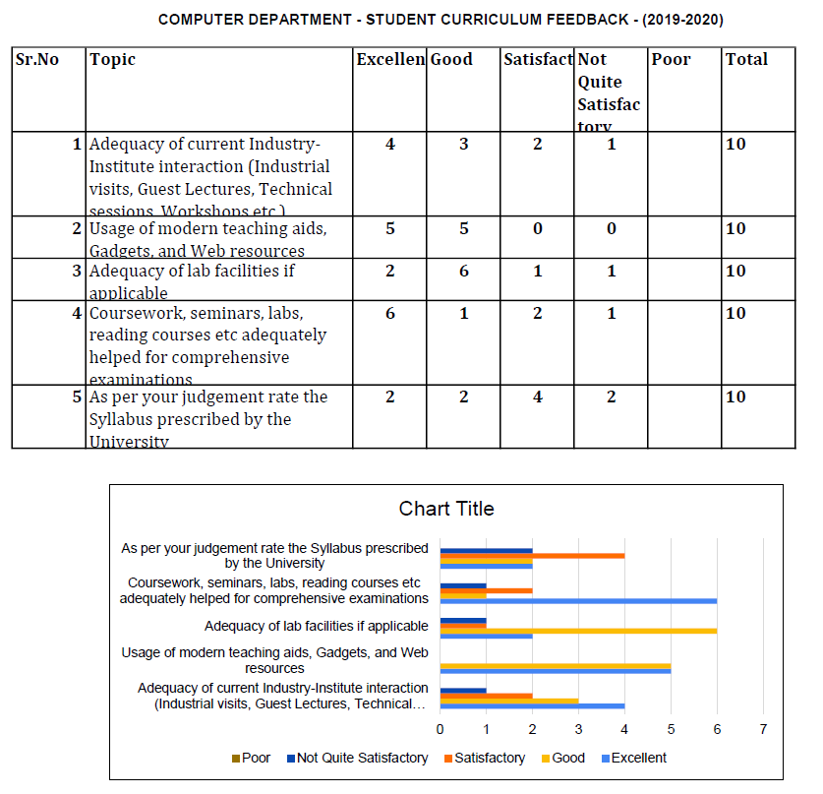

 | ELECTRONICS DEPARTMENT - STUDENTS FEEDBACK - YEAR 2019-2020
Sr.No | Topic | Excellent | Good | Satisfactory | Not Quite Satisfactory | Poor | Total
1 | Adequacy of current Industry-Institute interaction (Industrial visits, Guest Lectures, Technical sessions, Workshops etc.) | 13 | 15 | 11 | 4 | 4 | 47
2 | Usage of modern teaching aids, Gadgets, and Web resources | 17 | 22 | 5 | 3 | 0 | 47
3 | Adequacy of lab facilities if applicable | 12 | 22 | 5 | 3 | 0 | 47
4 | Coursework, seminars, labs, reading courses etc adequately helped for comprehensive examinations | 18 | 16 | 10 | 2 | 1 | 47
5 | As per your judgement rate the Syllabus prescribed by the University | 11 | 15 | 14 | 6 | 1 | 47

 | INFORMATION TECHNOLOGY DEPARTMENT - STUDENT CURRICULUM FEEDBACK - (2019-2020)
Sr.No | Topic | Excellent | Good | Satisfactory | Not Quite Satisfactory | Poor | Total
1 | Adequacy of current Industry-Institute interaction (Industrial visits, Guest Lectures, Technical sessions, Workshops etc.) | 6 | 4 | 2 | 0 | 0 | 12
2 | Usage of modern teaching aids, Gadgets, and Web resources | 3 | 8 | 0 | 1 | 0 | 12
3 | Adequacy of lab facilities if applicable | 6 | 5 | 1 | 0 | 0 | 12
4 | Coursework, seminars, labs, reading courses etc adequately helped for comprehensive examinations | 8 | 3 | 0 | 1 | 0 | 12
5 | As per your judgement rate the Syllabus prescribed by the University | 1 | 10 | 1 | 0 | 0 | 12

